## 说明

本附件用于马思源（学号BA15004050）申请科技论文写作课学分使用。

本附件中包括：

1 TIPP会议组发来的邮件原文

2 邮件中的附件原文

3 接收函查询及接收函内容

4 会议论文原文原稿（导师签字）

|  |  |
| --- | --- |
| 主　题: | mail to authors |
| 发件人: | TIPP2017 <tipp2017@ihep.ac.cn>  2018-3-23 11:00:29 |
| 收件人: | 15555455329@163.com |
| 附　件: | mail to authors.docx |

Dear  authors:

     All the analysis results of duplicate checking from Springer has been finished and uploaded in the TIPP2017 Indico system. Everybody please try to check the excel file or pdf file for our submission. Please find the Attachment of this email that may help you find the files of checking result in Indico system.

    If you have an advice with “revision” or “ask for clarification”, please modify your writing according to the advice from Springer. And give us your final version before March 28, 2018.

    If the advice is “Do Not Proceed”, that means, with our regret, your submission is not accepted this time.

    If your advice is OK TO PROCEED, a notice will be sent to you if further modification is needed from the committee. For those who has not submitted the consent to publish document, please do submit soon before end of this March.

    Best regards,

    Wenxuan Gong

以上为TIPP会议组发来邮件，其中，附件内容如下：

First step: login the Indico system.(http://indico.ihep.ac.cn/event/6387) Then click ”upload paper ” at the left column.

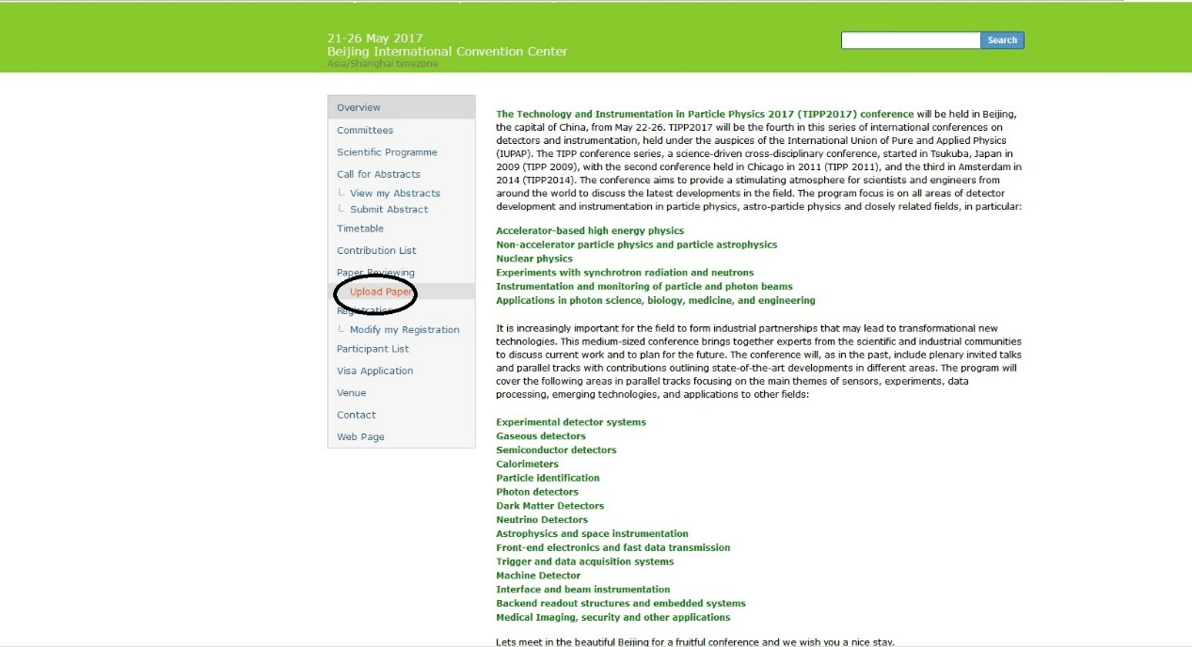

Second step: click “upload paper” at this page.

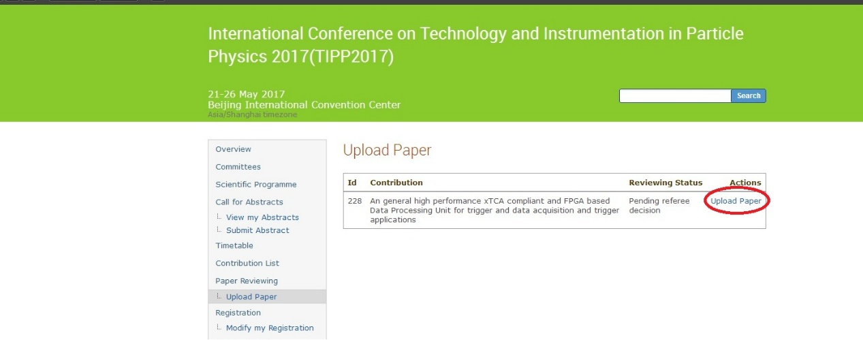

Third step: click “view paper ”, you may find a excel file that name include author’s contribution ID and name or a pdf file that name include contribution ID. You may check your result in this file.

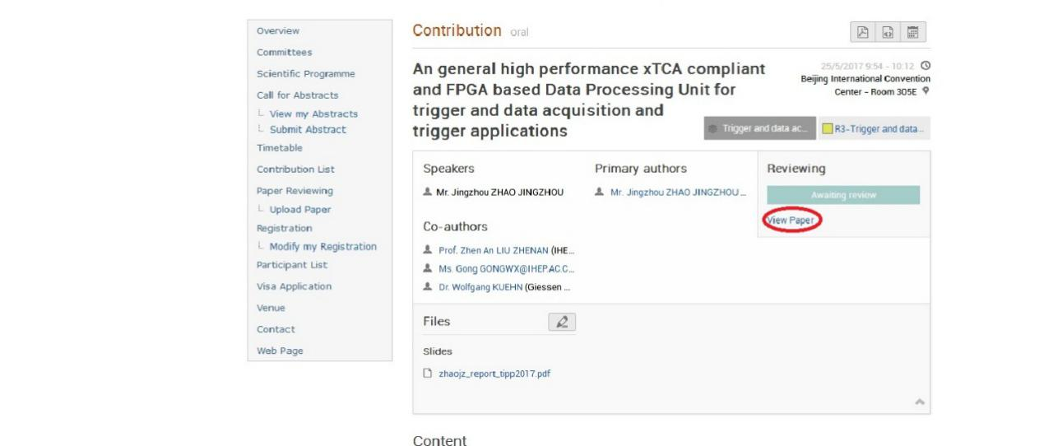

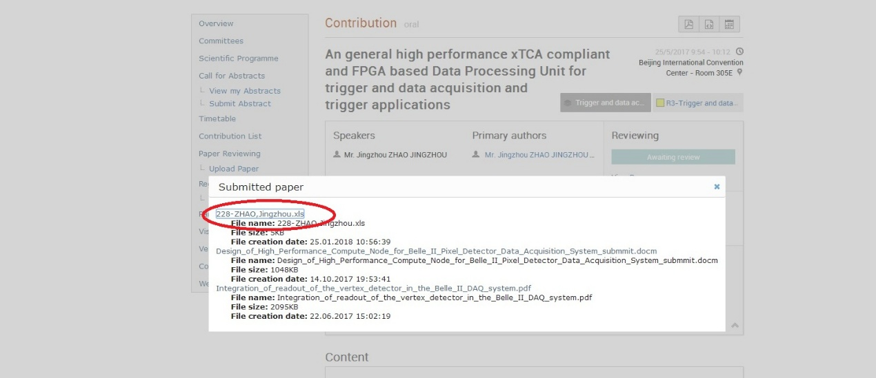

根据附件的内容，本人操作查询后结果如下：

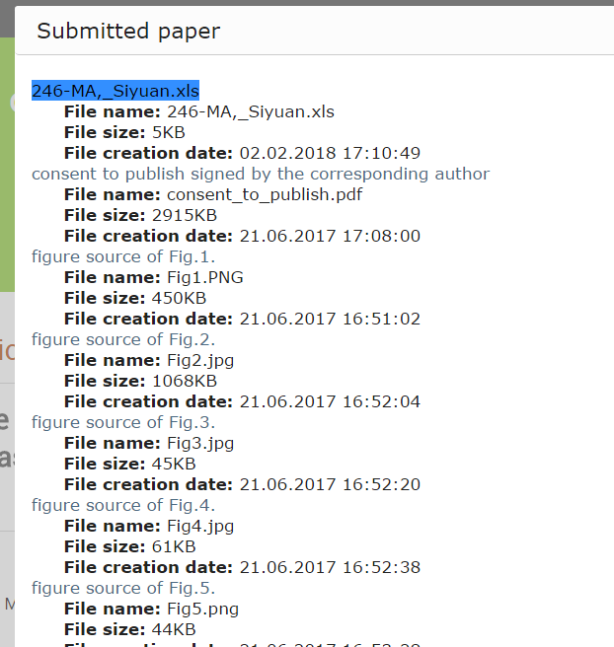

该xls文件中内容如下

|  |  |
| --- | --- |
| CHAPTER NUMBER | 246-MA, Siyuan |
| CHAPTER TITLE | A Portable Readout System for Micro-pattern Gas Detectors and Scintillation Detectors |
| PAGE COUNT | 4 |
| ITHENTICATE % | 9 |
| HIGHEST ITHENTICATE% FROM A SINGLE SOURCE | 2 |
| CROSS CHECK/ITHENTICATE RESULT | Okay to proceed |
| CROSS CHECK/ITHENTICATE RESULT COMMENTS |  |
| ENGLISH LANGUAGE QUALITY | Okay to proceed |
| ENGLISH LANGUAGE QUALITY COMMENTS | - |
| ETHICS COMPLIANCE | NA |
| ETHICS COMPLIANCE COMMENTS | - |
| FINAL ADVICE | Okay to proceed |
| FINAL ADVICE COMMENTS | - |

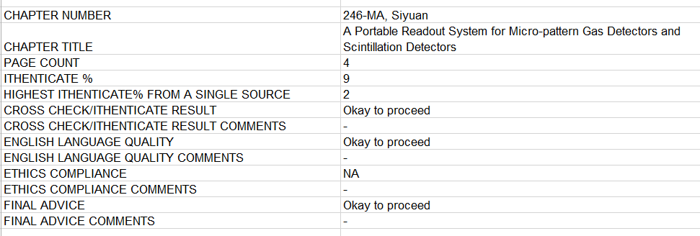

综上，文章已经同意发表并发来接收函，预计6月中旬正式发表。